**Mainframes DXC Australia**

**Notes**

**By: Pranay Yara**

**z/OS | Week 1** **1**

**TSO | Week 1** **4**

**JCL | Week 2** **5**

**JCL Utilities | Week 2 & 3** **9**

**COBOL | Week 4** **12**

**CICS | Week 4** **16**

**VSAM | Week 5** **21**

**DB2 | Week 6** **22**

**IMS | Week 6** **24**

# **z/OS | Week 1**

* **z/OS** is a zero down time operating system. So, systems using z/OS have minimal downtime, aiming for continuous availability.
* In z/OS everything must be communicated as a job. z/OS consists of many sub systems:
* There are two types of language in mainframes - **application language** (COBOL): building logic / commercial - business needs, insurance, retail market, airlines - any applications that are daily / customer needs. Opposite to that we have **control language** (JCL): is not a commercial, it's built to interrupt / will help communicate with the operating system not to build your commercial applications.
* mvs = z/os (everywhere you see mvs its z/os).
* IPL (initial program load) is basically the process for starting up z/os i.e. booting it up.
* **Name of datasets:** HLQ = Highest level qualifier, and LLQ = Lowest level qualifier.

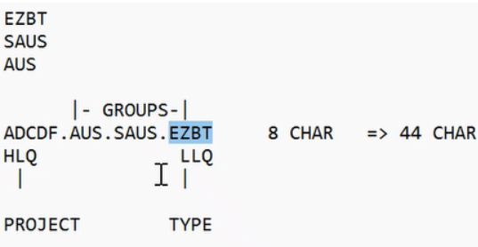

* Every qualifier name should not exceed 8 CHARs, and the total length of a dataset shouldn't exceed 44.
* **3 types of memory: auxiliary, real memory part of cpu, and virtual memory.**
* Disk keeps your data and program as a data to the disk = auxiliary memory
* cpu + electronic memory holds temporary data and program = real memory
* Whenever you edit it is in electronic/real memory, once you save it becomes auxiliary memory.
* Whatever you see is real memory, auxiliary memory is whatever you don't see like anything not on your screen, that is why we call it virtual memory.
* Auxiliary memory means if you don't get in your home you have to go to the store.
* Virtual memory: Virtual storage for dynamic file size increase.
* CPU is connected to the device tape disk, printer via lines called channel 5.
* **Tape vs Disk:** tape is sequential so it is slower, disk has many headers so it will immediately read.
* Important: programs running on z/os and ibm z mainframes can run with 24-bit, 31-bit, or 64-bit addressing.
* **Address Space** is if you are using a 31 bit machine then 31 is the address, if i'm using tso and tso is the address.
* Dynamic address translation, or **DAT**, is the process of translating a virtual address during a storage reference into the corresponding real address.

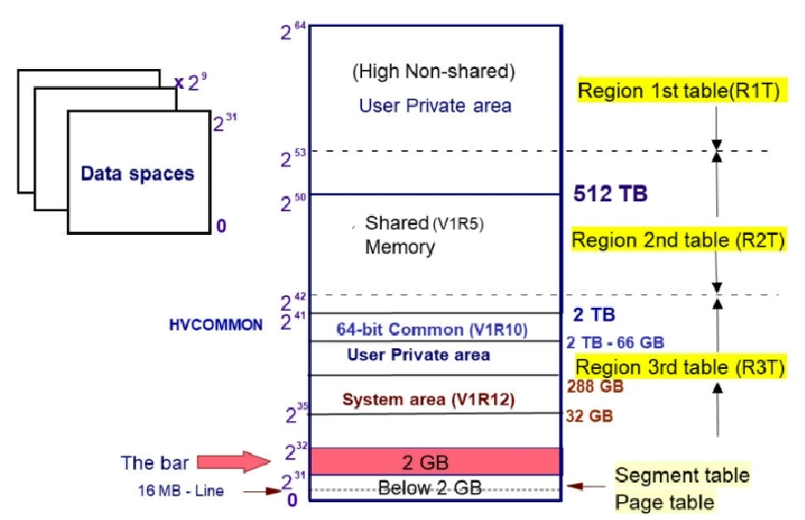

* **Under shared memory/data synchronisation** - like if there is ascii db (outside of mainframe) and db2 in mainframe - because of internal stakeholders using different / prefer unix or mainframe, any value will be duplicated so data is presented in both.
* **Page out** - because not referenced with a time limit. if there is no time limit reference then it will go out. for example page 1, 2 and 3. page 1 is page out while 2 and 3 are page in which means page 1 isnt time referenced.
* ieasys

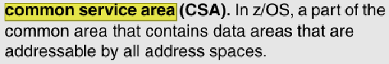

* CSA Range: Address range for a control section.
* Linkedlist: Data structure with elements linked in sequence.
* PSA: Prefixed Save Area; the lowest standard is zero for uninitialized areas.

# **TSO | Week 1**

* **Ispf** is an application in **tso** (tso is a bigger thing, within tso is ispf)
* **Datasets** have two purposes: either to store raw data (collection of records - a **record** is (ID)(NAME)(INFO) ‘01BOBENGINEER80000’) or to write code.
* Two types of datasets: **non VSAM** and VSAM (virtual storage access method). VSAM will be discussed in later weeks.
* In **non VSAM** dataset, there are two types of datasets: **PDS** (Partitioned Dataset) and **PS** (Physical Sequential).
* A **PDS** is a collection of members. Each member can have code. (A member is basically a file in a folder) - Can write JCL utilities in member files.   
  PDS JUST GROUPS THEM
* A **PS** file is an independent / scratch dataset, which either acts as an input or output to the program.
* Both PDS and PS files are **sequential**, what is a sequential file? where records are accessed 1 by 1.
* **Resource** is anything requested by the program (mostly input / out datasets)
* **1st attribute:** **name**, each qualifier cannot have more than 8 characters and the total string can't be more than 44 characters.
* **2nd attribute: space units / DASD**, (direct access storage device) understands space memory in tracks and cylinders (you can call it in kb but the regular way is tracks).
* DASD technical name SYSDA 3390 for device type which will be default so you don't have to enter anything. Dasd / device is where your files are created into / stored.
* **3rd attribute:** **primary quality**, deals with number of space numbers. when you first allocate a file, the primary quality is initial size.
* **4th attribute:** **secondary quantity**, will always be allocated based on the **extend** when the primary quantity is full.
* Max / default extend values for non VSAM is 16, in VSAM it's 128. so if the secondary quantity is 5 then 5x16=80 new tracks after the primary quantity is filled.
* When the primary quantity gets full, all of the secondary quantity ‘80’ gets allocated.
* **5th attribute: record size** is the physical length of each record - max characters allocate 80 bytes.
* File, field is a collection of records and record is a collection of fields.
* **6th attribute: block size** = cup / collection of records together. If 80 is max record size then 800 is block size.
* fixed length = 1 record per row, variable length record = variable record per row

.

* 99% go for fixed because for variables we have to keep track of starting and ending as for fixed we already know.
* **7th attribute: record format**: fixed block is best. Also, the block depends on the record. (find out the other ones like undefined, fixed, block, etc in recording)
* 8-9 are very important because they differentiate between pds and ps.
* **8th attribute: directory value**: for ps its 0. for pds there should be any value - try to use 5 for 5 members.
* **9th attribute: Dataset organisation**: for ps its blank, for pds its pds.
* Organisation for pds is p0 and for ps is PS

# **JCL | Week 2**

* z/OS doesn't understand input, according to it everything is a job. So if you want to input data you have to communicate it as a job (compilation is a job and executing is another job / a request from the user) - users may have various requests, every request must be submitted as a job so through a file/program. The JCL / COBOL is not a job, to make it a job you first have to **compile** it and then **execute** it. The file is a pds member.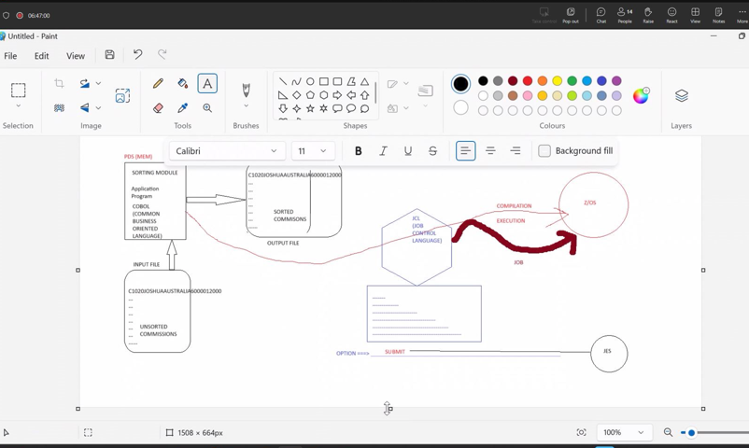
* **JCL** is a control language that works with executing. **Why JCL?** it acts as an interface between application program and interface.
* For an application program to be executed - you can communicate to the operating system by writing and sending a JCL code (jcl is similar to intermediaries).
* JCL code provides the **specifications/properties** to execute a job.
* JCL is case sensitive and only allows caps.
* JCL has to be submitted in command line with the command 'submit' and once submitted it goes to one of the sub systems under z/os called **JES** (job entry system)
* **Jes** (job entry subsystem) is the first sub system because through jes all the other subsystems activate. Jes provides the operating environment.
* JES uses virtual temporary address space to process all jobs which is called a spool area. Spool area is made up of queues: **1. input queue, 2. output queue, 3. held queue, 4. active users queue, 5. status of the jobs queue.**
* In spool/sdsf there is **da (display active)** which shows all the jobs currently running: **white colour** jobs are system jobs (services required by the system), **blue colour** jobs are user submitted jobs (not a service).
* **Jes phases: 1. input phase:** Jes receives the submitted job and puts it into the input queue. Always input queue is a job to be executed / yet to be processed. Now, imagine a real system - there are a lot of jobs) Once Jes receives all the jobs (found in input queue), then **2. scheduling** takes place. A scheduling is a process of arranging all the jobs according to its priority - i.e. the priorities are just numbers 0 to 15. higher the number, higher the priority. lower the number, lower the priority. (question - if same priority then it will be based on timestamp). The process of assigning highest to lowest priority is called scheduling. **2. Conversion phase:** it's the process of converting the high level language code into the machine level language instructions. **3. Executing:** all the machine level instructions (referred are your low level code) will be executed. **4. output:** nothing but the final result of your code so possible results can be4.1. encounter: with error: debug: ST queue or 4.2. output: ST queue or into the output file. **5. hard copy:**  printing the required outputs into any of the printing device.**6. purge:** a purge is a process of deleting the successive submitted jobs which you do not required in the spool area.

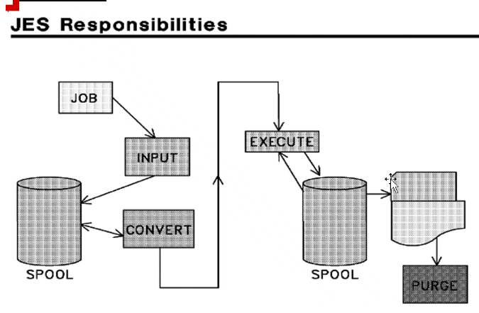

* So, an application sends an input job to **JES** with **JCL** language to communicate with operating systems then the operating system sends back an output file to jes and is viewable in the spool area.
* After submitting a job where do I see the output or if my program is encountering an error? in the spool area. For **JCL errors** go to ‘JESMSGLG’ and for **MAXCC errors** go to sysprint.
* In JCL, there are **3 statements: job. exec, dd** (this should be in hierarchy - job comes first - then exec and then dd)
* **first statement: job** will create a new job, second statement: if you would like execution then it will be done by the **next statement: exec** and a job can have more than 1 exec statements in it. (1 exec can execute 1 program) - each step is an exec statement. Each program requires resources which will be **identified as dd.** (one dd statement can only support one resource). 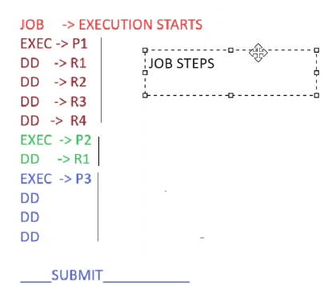

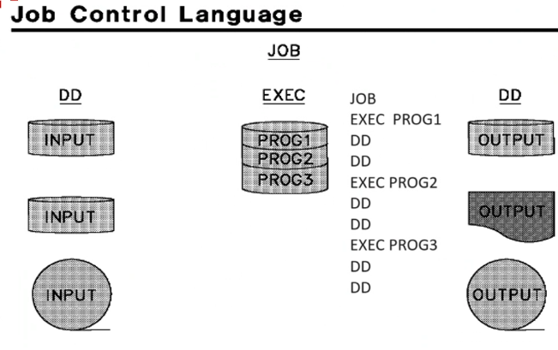

* Every JCL File has fields: **IF** (identifier field), **NF** (name field), **OF** (operation field), **OP** (operands/parameters) and **CF** (comment field).

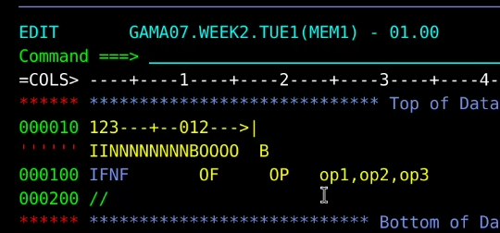

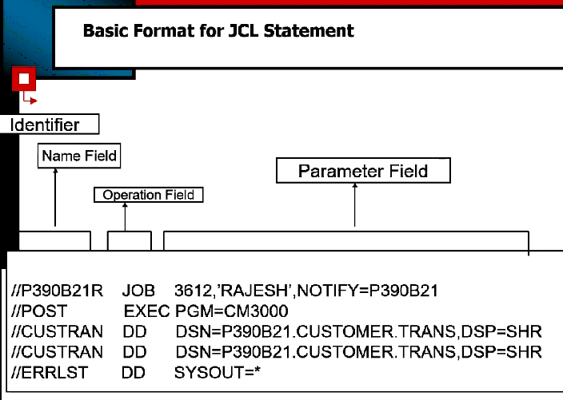

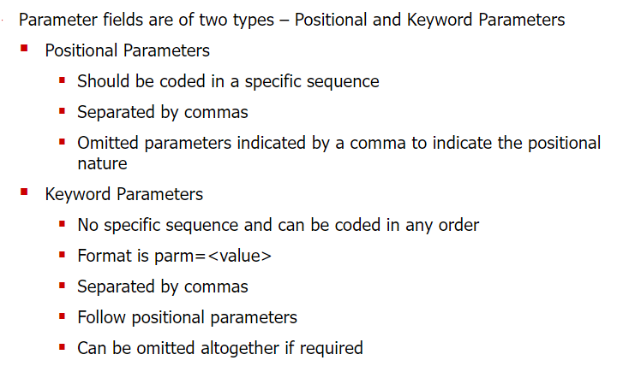

**JCL Statements: JOB** (max 255)**, EXEC** (max 255)**, DD** (3273)

**Parameters for JOB statement:** Positional parameters don't have = while keyword have it.

**Positional Parameters:** ACCT (Account Information), NAME

**Keyword Parameters:**

* MSGLEVEL -specifies the messages generated in the output. Default is (1,1).
* MSGCLASS - specifies the job output class. Class can be from A-Z, 1-9.
* TYPRUN - = SCAN checks for JCL syntax & format errors. Or = HOLD for later exec.
* PRTY - assigns priority to the jobs. 1-15, 15 gets the highest priority.
* CLASS - an input queue for holding jobs awaiting execution. A to Z and 0 to 9.
* RESTART - specifies the step name from which the job needs to be restarted.
* REGION - maximum amount of memory that can be allotted for the job. Optimal= 0m.
* TIME - maximum time that the JOB can take to run.
* NOTIFY - notifies you when a job is submitted and tells you the max cc code.
* **COND** - is for decision making, its like an if statement **syntax:** is cond=(relation condition,relation operator,previous step /stepname) - Can be coded in JOB or EXEC
* **Conditions** are **boolean** bytes so true or false. **false=execute**, **true=bypass/skip**.
* **0** is a sucess, **4** is a warning, **8** is syntax error, **12** dataset error, **16** utilility control statement errors.
* **cond=only,** means that previous step must be abended then step will get executed. **cond=even,** run steps even though any of the previous steps has abended.
* COND=only when you want to skip the step

**DD Statement:**  
 DD DSN='FILE.PATH',DISP=(NEW,CALTG,DELETE)   
 UNIT=3390,VOL=SER=DEVHD1,SPACE=(TRK,(5,5)),   
 DCB (DATA CONTROL BLOCK) =(RECFM=FB,LRECL=80,BLKSIZE=800,DSORG=PS) 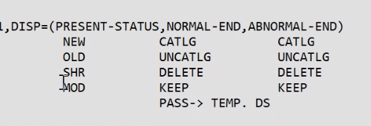

**Special dd names:** SYSUT1 SYSUT2, SYSIN SYSOUT

**Sysout** =* prints output  
**Sysprint** =* prints error messages   
**Sysin** = */dummy / dummy if here is no follow up or input data otherwise *

# JCL Utilities | Week 2 & 3

**IEFBR14: DUMMY UTILITY**

* used for creating a ps/pds dataset - disp=(new,catlg) **temp** &&name disp=(new,pass)
* deleting an existing dataset - disp=(old,delete)
* catalog and uncatalog dataset - disp=(old,catlg/uncatlg)
* creating GDG generations - filename(+1), disp=(new,catlg) // MOD to append

**IEBGENER:**

* **Copying** data from one PS to another PS. **SYSUT1** (in) and **SYSUT2** (out).
* Can also **concatenate** multiple ps files. By having multiple DSN in SYSUT1.

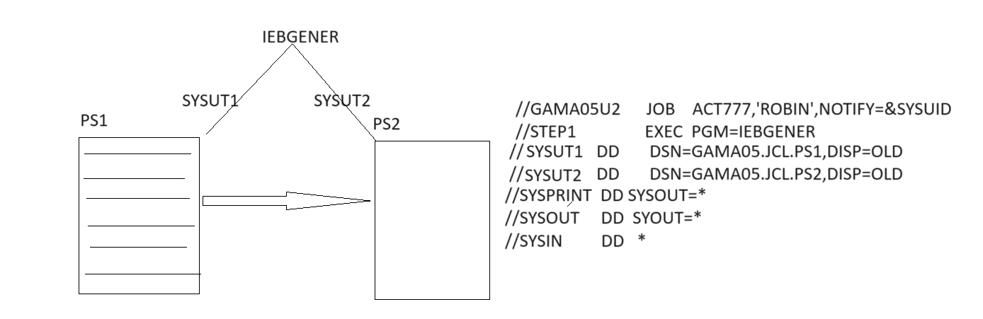

**IEBCOPY:**

* **Copies members** from one PDS to another PDS. **COPY** INDD=dd1,OUTDD=dd2
* Con also **compress** PDS. COPY INDD=dd1,OUTDD=dd1
* You can: SELECT MEMBERS=, EXCLUDE MEMBERS=, replace by (name, ,R) 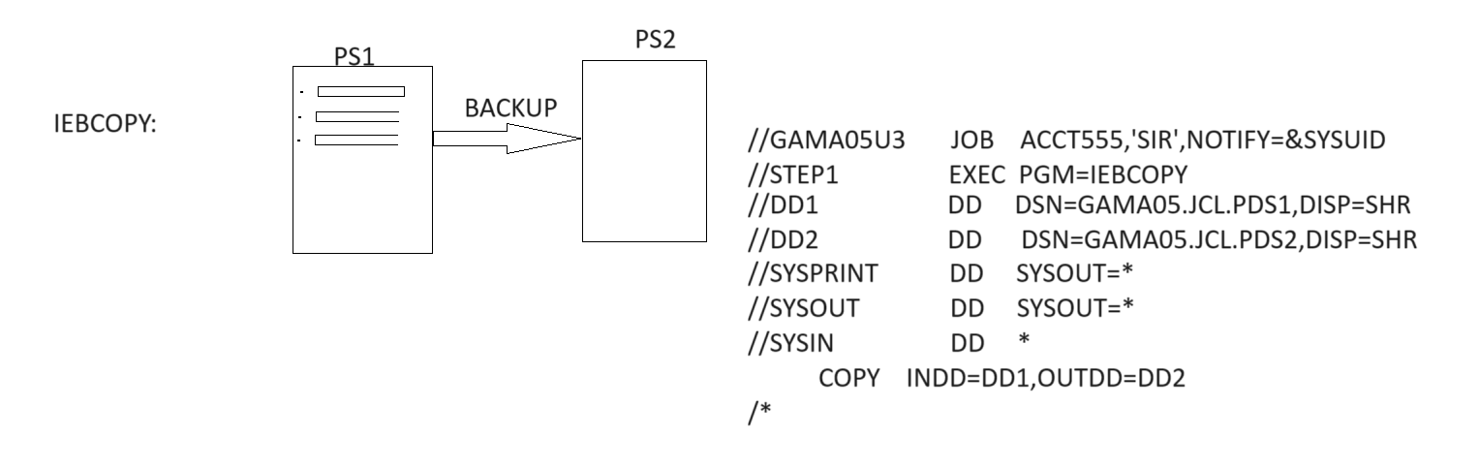

**SORT:**

* **Sort** SORT FIELDS=(starting point (sp), length, CH or ZD, and A or D), eliminate duplicates with SUM FIELDS=NONE, **Merge** MERGE FIELDS=(1,6,zd,A), **Copy** SORT FIELDS=COPY, **Split** OUTFIL, INCLUDE= and **format** datasets inrec/outrec.
* **Merge vs Concat:**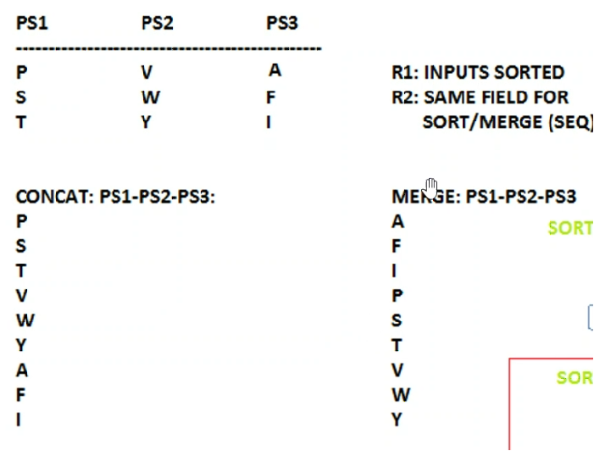

**Procedure** is a collection of pretested JCL statements. There are two types: **Instream procedures** (max 15) are defined and executed within the same JCL. **Catalog procedures** are pre-defined and stored in a procedure library, and they can be called by any JCL.

* **Instream Procedure:** Defined between the PROC and PEND statements within JCL.
* **Catalog Procedure:** Referred to using the EXEC statement with the PROC name.

**Symbolic parameters** are placeholders used in procedures to allow flexibility and reusability. **Syntax:** They are substituted with actual values when the procedure is invoked. Symbolic parameters are defined with an ampersand (&) in the procedure and replaced by actual values in the EXEC statement.

**Gdg** (generation data group) is a collection of like-named datasets which are chronologically related to each other. the **two rules;** first you create a gbg base with idcams and then you create a generation with iefbr14. Current generation will always be zero.

**Syntax:**

The parameters in a GDG BASE MODE:

* **DEFINE** GDG(NAME(ID.JCLMYBASE) to be the gdg base name.
* **LIMIT**(5) is maximum 5 generations **max is 255**.
* **noempty**: when limit is max, and you roll in a new generation then the oldest generation will get rolled off which means it gets uncataloged. **empty**: when the limit is max, and you roll in a new generation then all the existing generations will be rolled off, only the new generation will be present.
* **scratch** means the uncatalog will be deleted, **noscratch** means the uncataloged generations should not be deleted.

**Referback** - referring back to a previously dd statement.

*.STEP-NAME.DD-NAME -< REF. BETWEEN THE STEPS   
*.DD-NAME -< REF. WITHIN A STEP 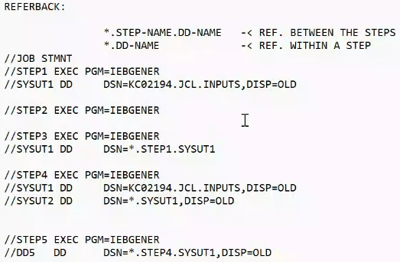

# COBOL | Week 4

* **COBOL** stands for **co**mmon **b**usiness **o**riented **l**anguage **- application language** - can create commercial applications - mainly for commercial domains for example banking, finance and insurance - not for system development.
* Cobol is simple compared to java - anyone can learn easily its like english language.
* Cobol structure is like a book structure - it will have chapters, paragraphs, sentences, words. So to make a paragraph or sentence you need a word, likewise in every programming language.
* There are **reserved and user defined words** which combine to make a program.

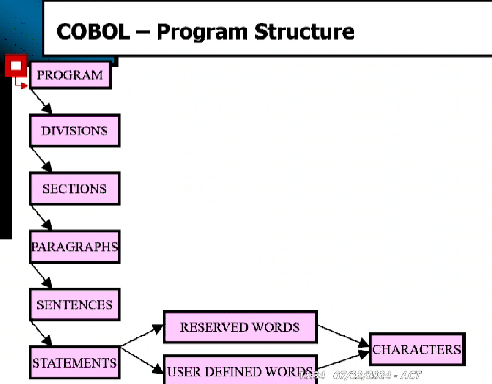

* Characters allowed in Cobol: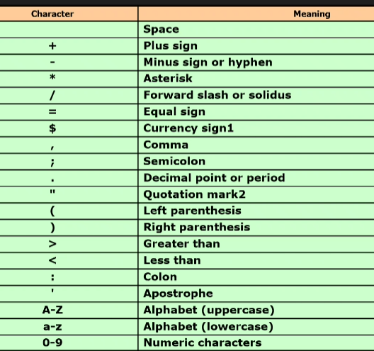
* Cobol consists of **four divisions.** which are in hierarchy: the first division is called the identification division, the second division is called the environment division, the third division is called the data division and the fourth is called the procedure division.
* **Identification division -** providing the basic details about the program, creator, when was it last compiled, which organisation - this is compulsory for every program. Best practice to keep this small as possible.
* **Environment division -** is the place around you - it means you are going to access the files around it - for external resources. if there is no need for external resources for the program then environment division is not needed. Optional for programs.
* **Data division -** declaration variables - all declaration is done in data / data within the program.
* **procedure division -** starting point / entry point of the cobol program - all your code goes here / all the executable statements.
* **Two sections under environment:** configuration and then input/output, nowadays we are not using configuration to identify the computers. To access a file you need an environment and input/output section - file to program is input, program to file is output. under the input/output section we have a paragraph called file hypen control . under the file control we talk about file.
* In Cobol data division has different declarations and every declaration has its own purpose: file section to build a record structure, **working-storage section** to declare the local variables, **linkage section** is for sharing variables with other files, report section and screen section.
* **Cobol rules -** first six columns you cannot code in. column 7 is indicator column on this column three values are allowed - * (comments) - (when you it break into two pieces) / (don't use it now) - the rest of the columns 8 - 72 is split into two different areas, area A (8-11 cols - these are starting points and can continue to 72 / divisions, sections, paragraphs should start with area A) and area B (12-27 all you statements and sentences should start from area B).
* Cobol verbs are done in procedure division. With the help of verbs we can make an execution program - without verbs you can't make executable programs.
* in cobol all the variables are called as identifiers.
* Space/blank is not allowed in paragraph names. to connect the words you can use '-' hyphen and use numbers.
* **Three basic cobol verbs / display, accept and stoprun** are coded on area B.
* Display verb - prints to the spool - can use one or multiple literal / identifiers or combinations then multiple things will be printed. 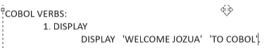

* Stop run verb - at end of cobol program.
* final output is from load module which gives binary format - load ,module is the output for cobol 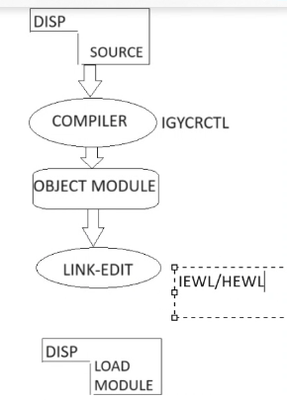
* JCL acts as an interface between COBOL application program and operating system.  
  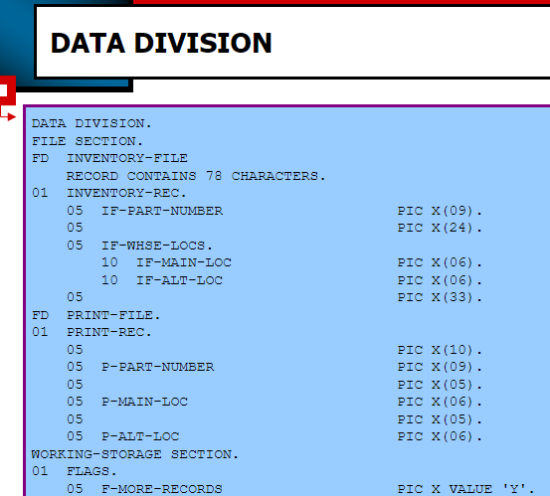
* **template** i should follow to declare a identifier:

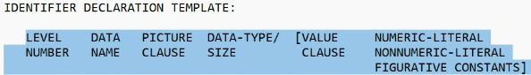

* Data name - you require bytes where you provide a unique name.
* Next, data type: where there are symbols which act as a data type.
* Entire language is made up of classes. Likewise, all these symbols in data type are offered by a picture class.

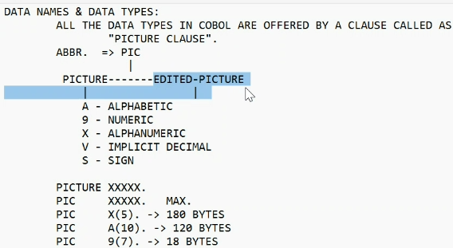

* **level numbers** have hierarchy - hierarchy means one after another - focus on two levels 01 - 77 which are independent items.

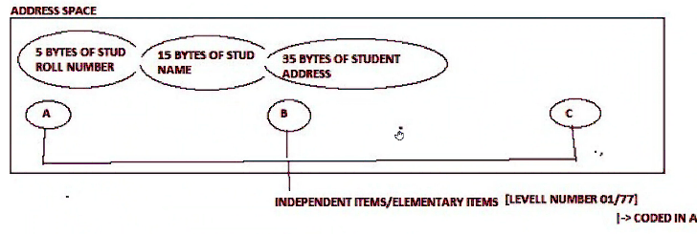

* Look A and B are not consecutive like one after another so we can call them independent. so we can use 01 or 77 for level numbers. if you don't use the value clause then the initial value for numeric will be 0 and for alphabetic it will be blank.
* Difference between 01 and 77 - **01 has record description.**
* **compute, add, subtract, multiply, divide** VERBs

# CICS | Week 4

It's a subsystem like JES. **Used to execute online programs for uses to interact with.**

**Transaction** is a request and response. To initiate a transaction, we have to provide a transaction id 4 bytes long).

**Terminal** understands transaction id, **CICS** understands commands.

Terminal is where a customer does tasks.

**Two types of transaction ids:** CICS Supplied and User Defined. **difference is:** CICS always start with C and user defined ids cannot start with C.

**online program created** in tso/ispf, compile in jcl - **how to compile?** with sub, execute in CICS, **how to execute?** you define transaction id (which is user define) first then the application program and install / update. **Then execution** in terminal.

**CICS commands:** 1. Send, 2. Receive, 3. Return (to stop / end)

cus: provide transaction id then enter -> you: send empty map to the terminal / what else can you send? has to be empty -> cus: fill pnr number (populating the map) and click submit -> you: recieve the populated map from customer (the pnr number) -> you: file related commands and collect information from the databases so send - file/data processing with filled info -> and finally after sending the filled info - the response is over return.

**ceda** - can do administrator activities - examples: **Define and Install** (can only define here)

**cemt** - execute master terminal - is a level 2 transaction id - for operators - you can use **inquire** check everything that is installed - can also install with SET

**ceci** - is for doing prototypes or / testing without the application program. For example printing a map you can use the syntax: SEND MAP(name) MAPSET(name). Can also use other cics command such as write, read, rewrite, delete

**Queue:** is a collection of items. Two types of queues - ts (temporary storage) queues and td (temporary data) queues.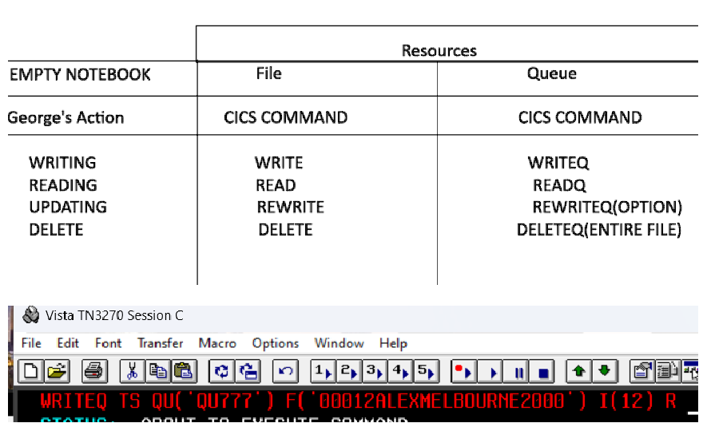

cesf - sign off /logoff

cesn - sign on /login

CEBR - EXECUTION BROWSE - to check queue

CECI COMMANDS: (R is for rewrite its optional)

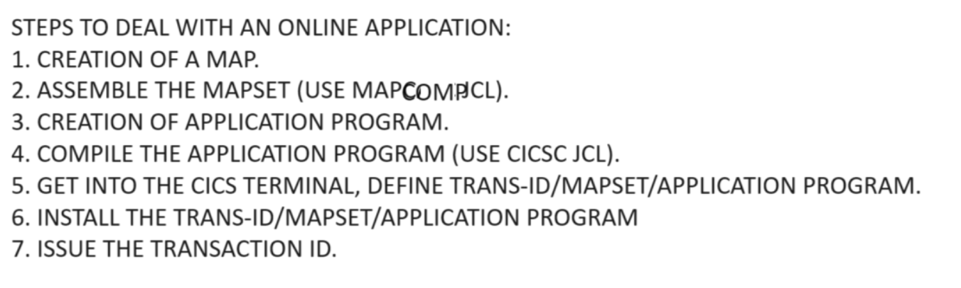

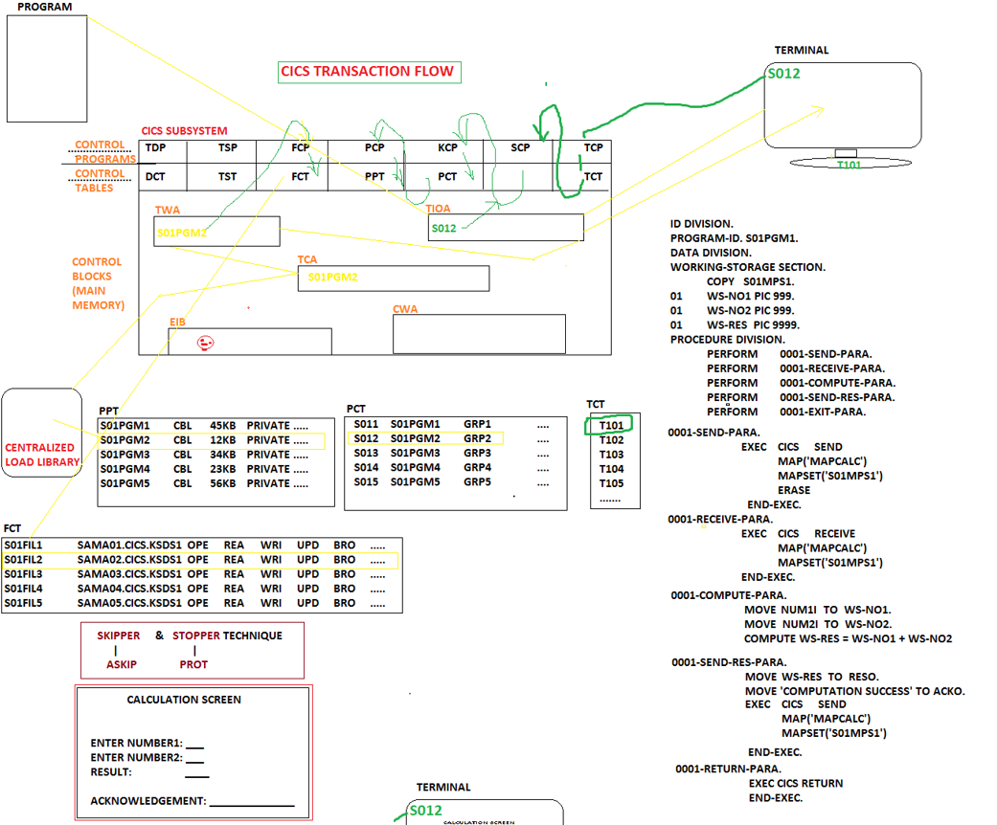

## 

## 

**Map** is output interface it’s for the users. **Two types of**: Physical map consists of physical fields and protected fields. **Symbolic map** consists of symbolic fields and unprotected fields.

Mapset is a collection of maps, a map is a collection of fields.

**BMS** (basic mapping sort) is made up of marcos and assembly language - there are three macros.

* **DFHMSD** is for mapset definition.
* **DFHMDI** is for map definition.
* **DFHMDF** is for field definition.

**COPYBOOK** is a pds member = SYMBOLC MAP - it's made after you submit a mapset - you can see all the input and output variables

when you request you receive two numbers from the symbolic playbook (**input flow**). One of the two numbers will be from no1i and the next will be found in no2i. to deliver you need to use no1o (**output flow**).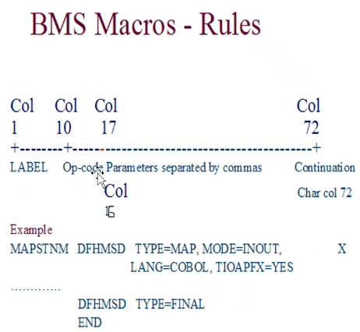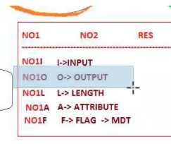

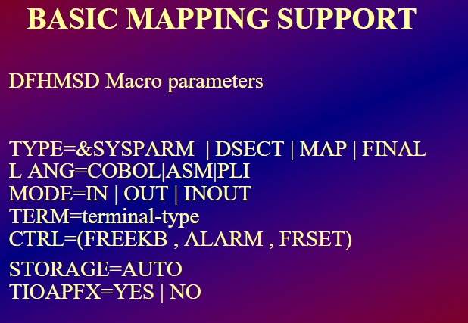

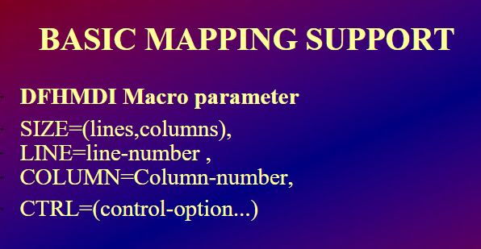

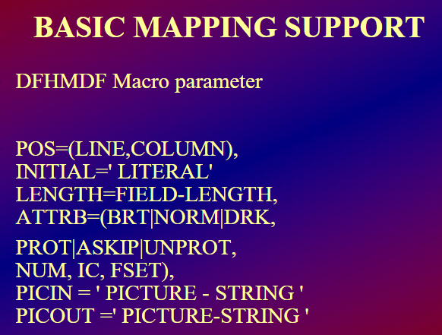

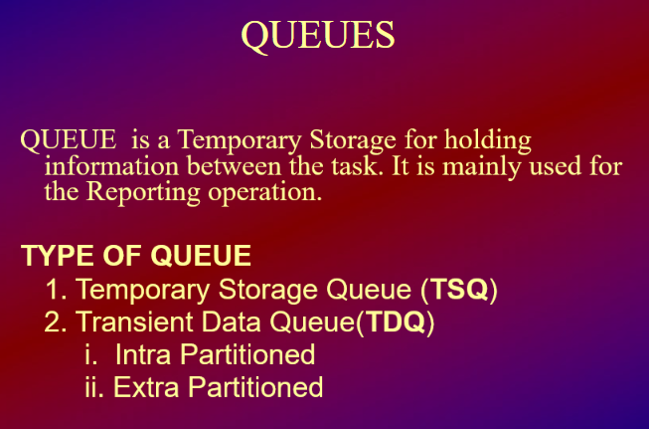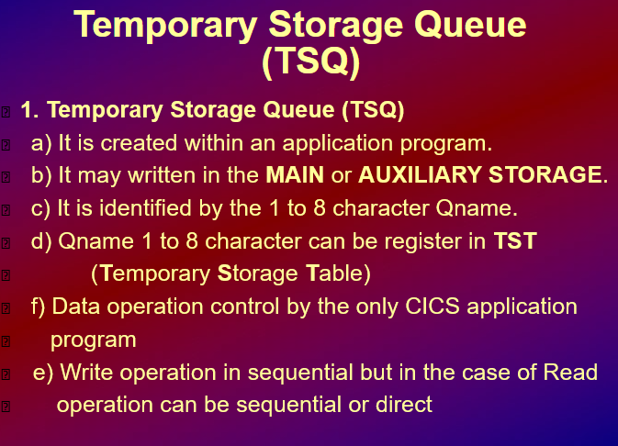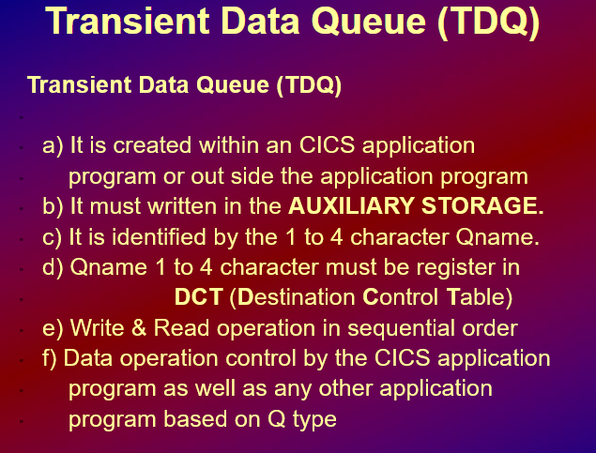

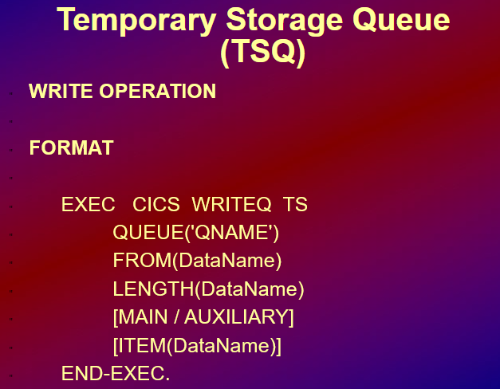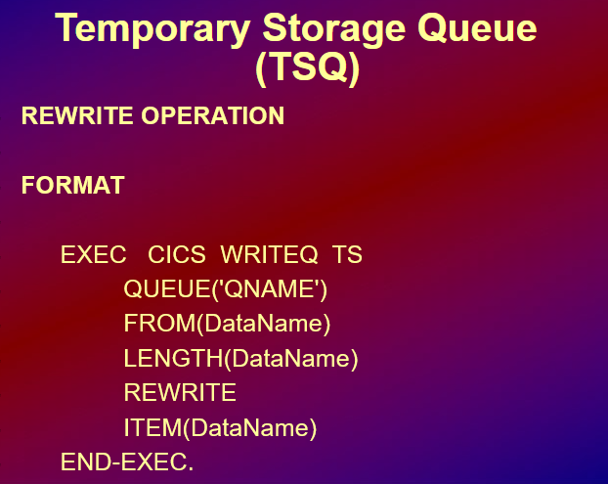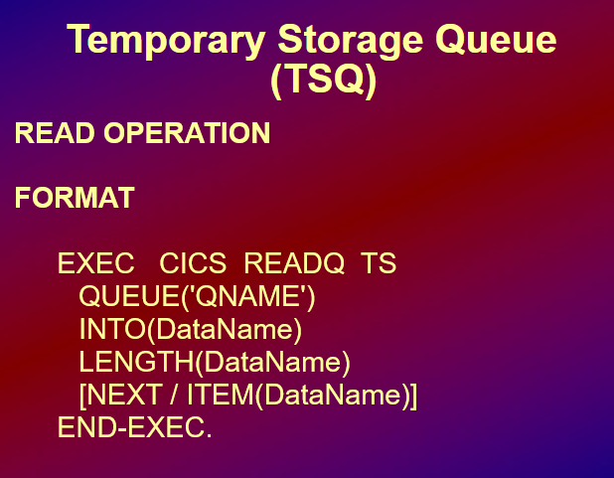

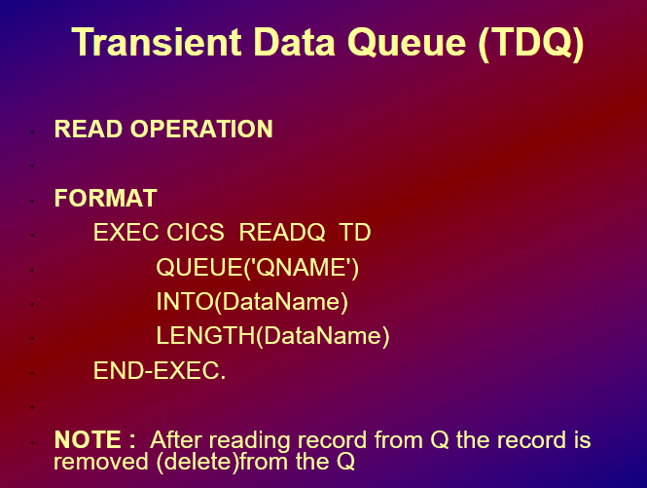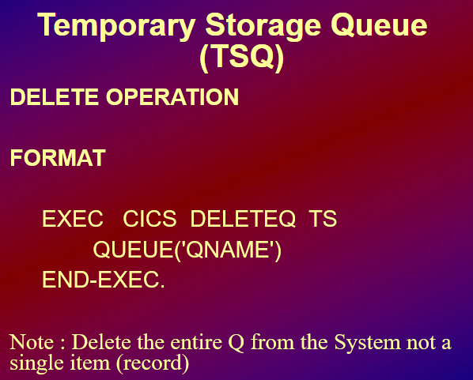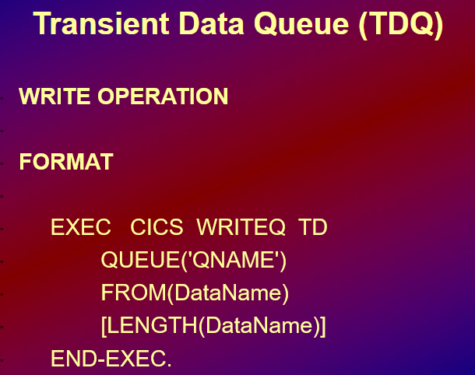

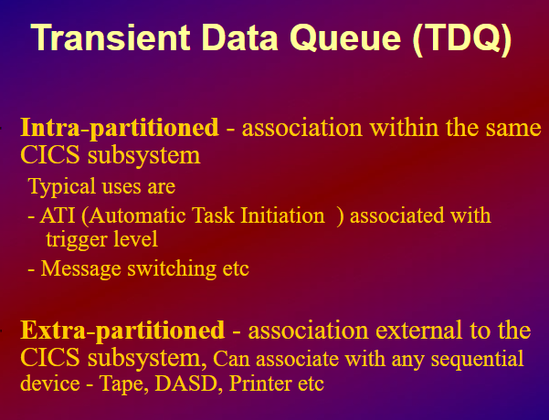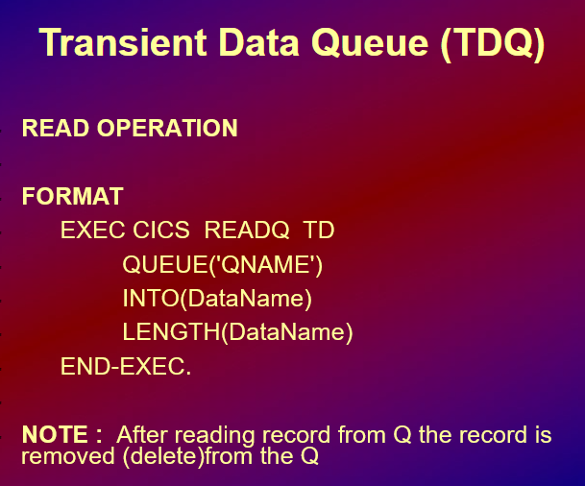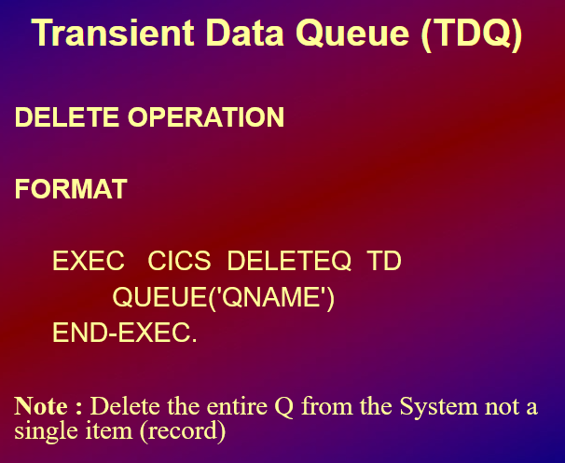

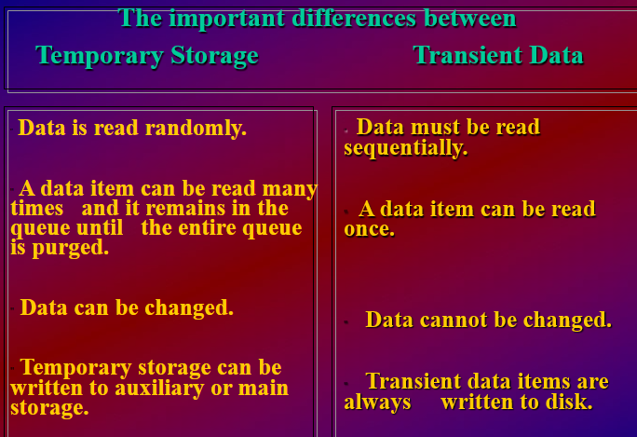

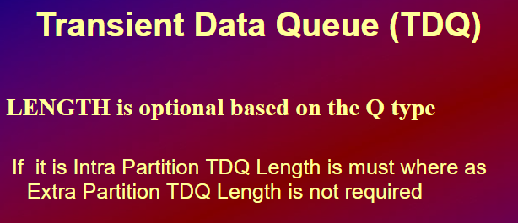

# VSAM | Week 5

**VSAM Datasets** are known as clusters - **cluster** provides building block/structure = **collection of records to vsam.**

**Also Cluster** offers **components** to hold records. One of the components is data where all the data is stored. In catalog for vsam datasets you will get a **minimum of two entries** one for cluster and one for data.

**types of vsam datasets:** esds, ksds, linear ds and rrds. also only more vrrds (extensive version of rrds).

* esds - non indexed - sequential - entry sequeitanl dataset. will store inputs exactly as given - raw data - can have alternative index
* ksds - indexed - you can select the key field. Duplicate records are not allowed, keys must be unique - can have alternative index
* rrds - numbered - similar to esds but numbered, unlike esds cannot be variable length for that we can use vrrds - cannot have alternative index
* Lds - linear

Jcl utility is dedicated with vsam. Unload - fromaddress/toaddres, Load - Count , Skip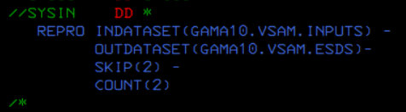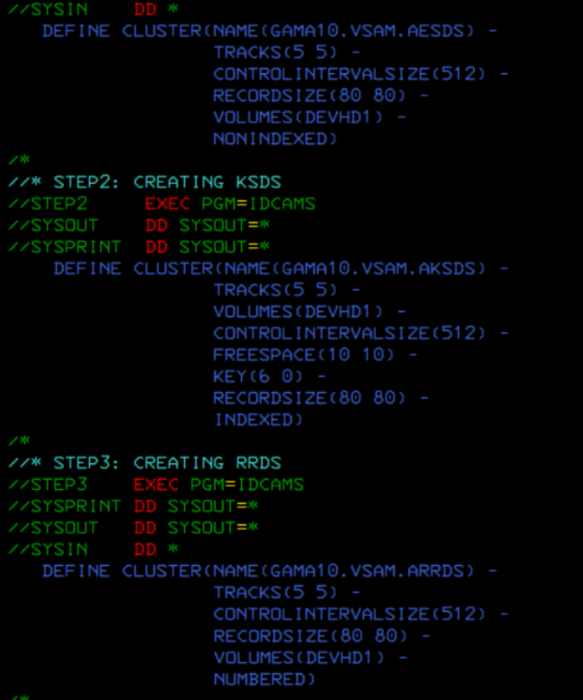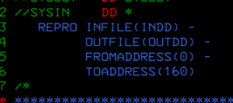

Printing default is dump; have to specify char or hex

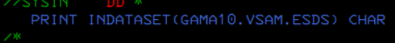

According to cluster starting point is 0, that's why we call it an offset.

**rba** (relative byte address) is the record's starting point starting the index from 0 not 1. rba is how cluster identifies the records in it

**Alternate Index (AIX)** is used to access a KSDS (Key-Sequenced Data Set) file using a key that is different from the primary key.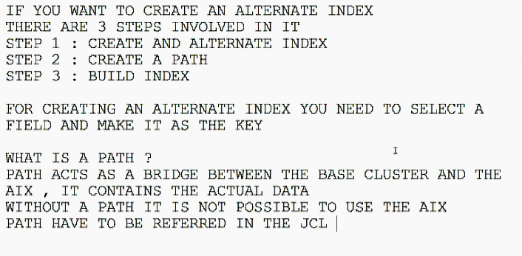

Data in the cluster gets stored in the **control interval.** (four things are logical space, free space - to add new records, ci, rdf) minimum for control interval is track (512) and max is cylinder (4096) Everything outside is a **control area**.

Data in kskds is stored in control areas and these control areas have control intervals

**LOAD** is when you collect from another ps. for example: every 6 hours for an atm in real life you have to use the load utility and the data will be stored in a database. load values? Values from the file you collect.

Ways to **print vsam** datasets: 1st way **spool** u can view vsam cluster. 2nd way **catalog** ‘print ids)’ code to print. 3rd way **file manager.** 4th way is with **ditto** 1-3 and enter name in ' '.

# DB2 | Week 6

DB2 is a database management system that provides a comprehensive environment for managing and manipulating data. Understanding the various SQL statements and their corresponding keywords is crucial for effectively working with DB2.

**SQL Statements (4 Categories)**

**1. Data Definition Language (DDL) Statements**

DDL statements define and manage the structure of database objects. The primary DDL statements are:

* **CREATE**: Creates a new table, view, index, or other database objects.
* **ALTER**: Modifies an existing database object, such as a table.
* **RENAME**: Renames a database object.
* **DROP**: Deletes a database object.

**2. Data Manipulation Language (DML) Statements**

DML statements manipulate the data within the database. The primary DML statements are:

* **INSERT**: Adds new rows to a table.
* **SELECT**: Retrieves data from one or more tables.
* **UPDATE**: Modifies existing data within a table.
* **DELETE**: Removes rows from a table.

**3. Data Control Language (DCL) Statements**

DCL statements control access to data within the database. The primary DCL statements are:

* **GRANT**: Gives permissions to users to perform certain actions.
* **REVOKE**: Removes permissions from users.

**4. Transaction Control Language (TCL) Statements**

TCL statements manage the changes made by DML statements. The primary TCL statements are:

* **COMMIT**: Saves all changes made during the current transaction.
* **ROLLBACK**: Undoes all changes made during the current transaction.

Keywords

* **PRIMARY KEY**: Uniquely identifies each record in a table.
* **FOREIGN KEY**: Establishes a relationship between two tables.
* **UNIQUE KEY**: Ensures all values in a column are unique.

**Functions**

Arithmetic Functions:

Perform basic arithmetic operations:

* +, -, *, /

Scalar and Aggregate Functions:

**Scalar Functions**: Operate on each row and can be used in the WHERE clause.

* **CHAR**
* **BLOB**
* **BINARY**
* **BIGINT**
* **SMALLINT**
* **DATE**
* **DECIMAL**
* **DEGREES**
* **TIME**
* **HEX**

**String Functions**:

* **CONCAT**
* **STRIP**
* **TRIM**
* **SUBSTR**
* **STRPOS**
* **LOWER**
* **UPPER**

**Math Functions**:

* **ABS**
* **FLOAT**
* **FLOOR**
* **SQRT**
* **MIN**
* **MAX**

**Date/Time Functions**:

* **DAY**
* **MONTH**
* **DAYOFWEEK**
* **DAYS**
* **HOUR**

**Array Functions**: (Varies with specific DB2 implementations)

**Aggregate Functions**: Operate on multiple values (rows) and can only be used in the SELECT clause.

* **COUNT**
* **AVG**
* **MAX**
* **MIN**
* **SUM**
* **PERCENTILE_**\*
* **VARIANCE**

Querying from Multiple Tables

**Set Operations**:

* **UNION**: Combines the results of two or more queries.
* **INTERSECT**: Returns the common results of two queries.

**JOINs**:

* **INNER JOIN**: Returns rows that have matching values in both tables.
* **LEFT JOIN**: Returns all rows from the left table, and the matched rows from the right table.
* **RIGHT JOIN**: Returns all rows from the right table, and the matched rows from the left table.
* **OUTER JOIN**: Returns all rows when there is a match in one of the tables.
* **CROSS JOIN**: Returns the Cartesian product of the two tables.

# IMS | Week 6

* entity name in db2 is table - collection of tables // entity name in ims segment - collection of segments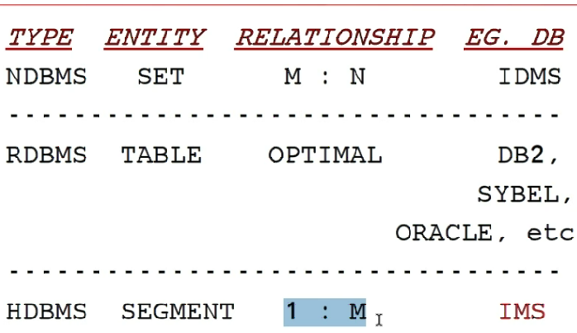
* Top down method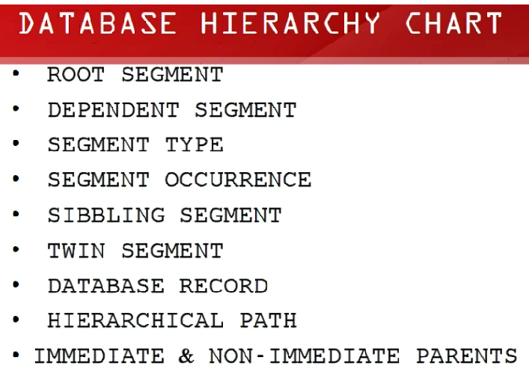

1. root is the parent,

2. rest/all below segments are called dependent segments.

file consists of records, table consists of rows

3. segment type is a unique name of the segment that consists of segment occurrences

4. 1 entry = one occurrences, in file its record, in db2 its a row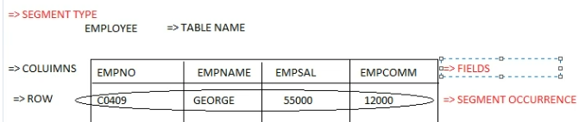

5. a sibling is the one when they are on the same level and share the same parents

3 patients -> p1 p2 p3 (3 total occurrences) p1> 3 illines (3 occurrences), p2- 1 illineses(occurrences) p3 -> 2 illines (occurrences)

6. twin segments are for a number of child occurrences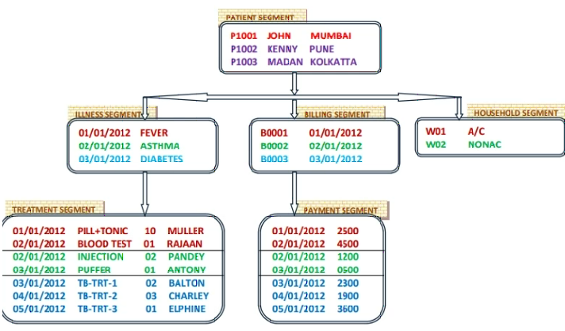

all blues in treatment segment is twins of diabetes

7. A database record is a collection of all the dependent segments / all occurrences that comes under the same root.

8. Hierarchical path top down column 1 is path 1, top down column 2 is path 2.

9. immediate parent is parent and non immediate parent is grandparent and goes up to the parent / except root every segment will have an immediate parent.

logical is when it view and database is not the same

**5 access methods:**

Hierarchical direct access method.

Hierarchical index sequential access method.

Hierarchical index direct access method

Hierarchical sequential access method.

Generalised sequential access method

# DFSMS | Week 7

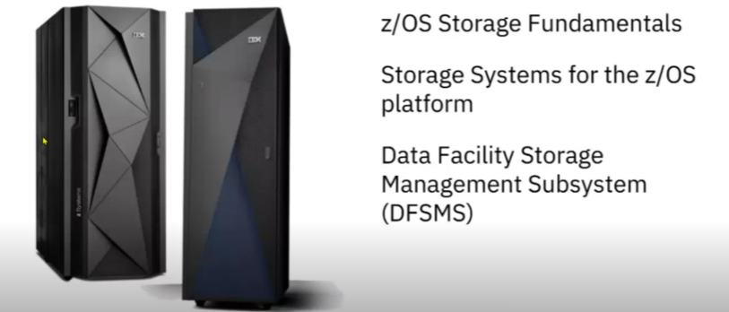

Left side is the mainframe server / mainframe, Right side is dasd box which is a hardware box which connects the data to the mainframe server

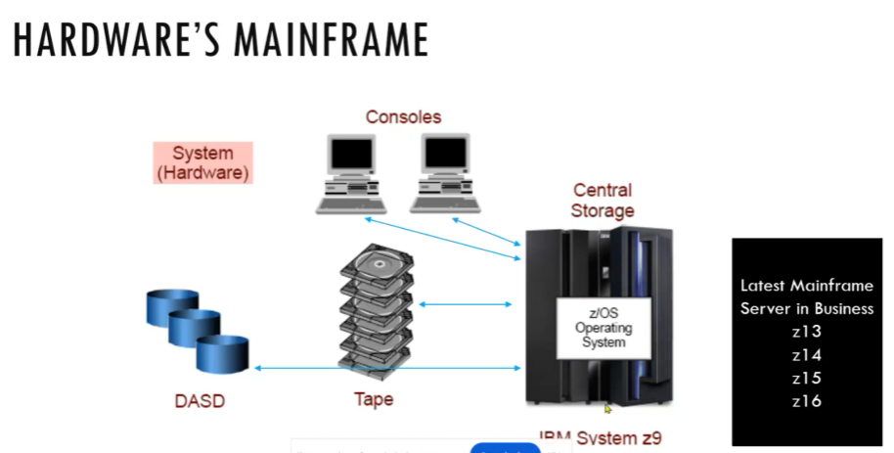

* There are many different hardware for example dasd and tape in z/os
* Storage manager jobs:
* Media administration to manage the hardware, verify any errors in hardware
* Space administration is managing the mainframe data stored
* Data administration is all about managing data that is created in dash, whether taking a backup, how many days the data should retained, whether the data performance should be increased, how to allocate a data either to lowest hardware or primary.
* Storage admin tasks: manages data, first part is installations, after that assist users for simplifying their JCL specifications

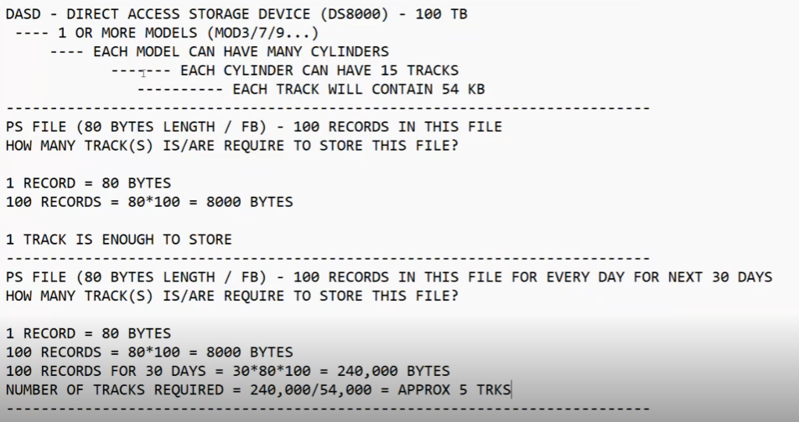

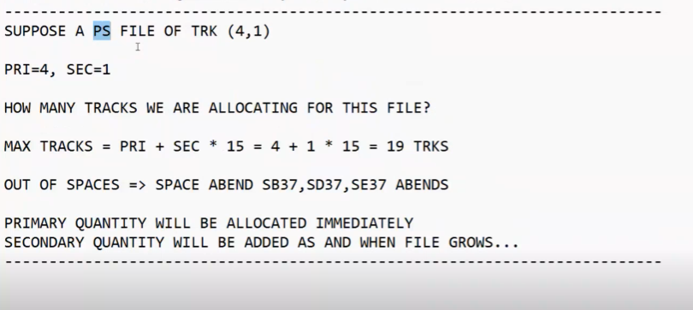

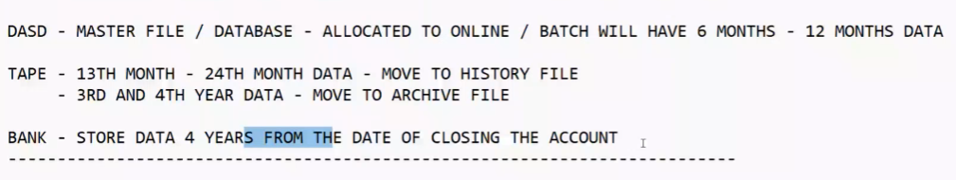

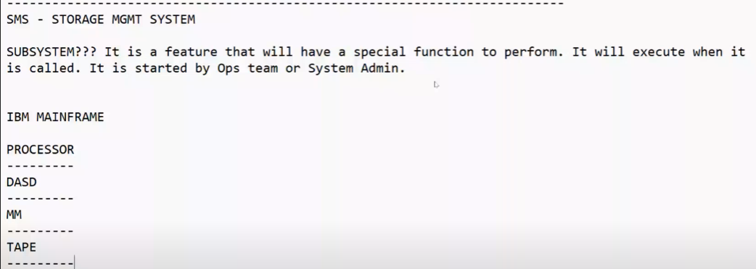

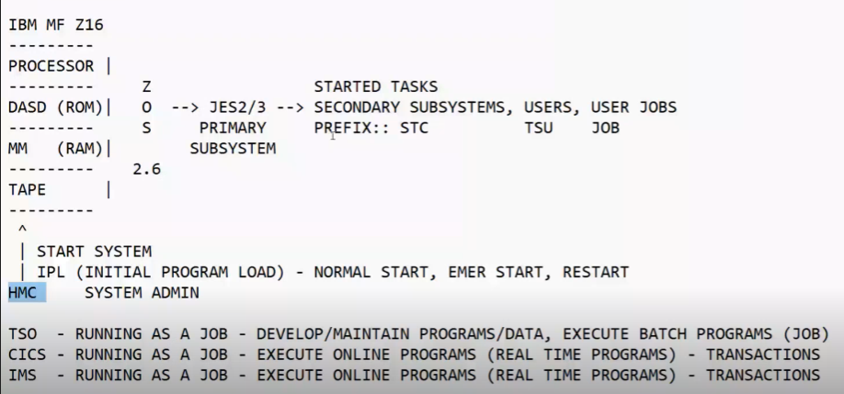

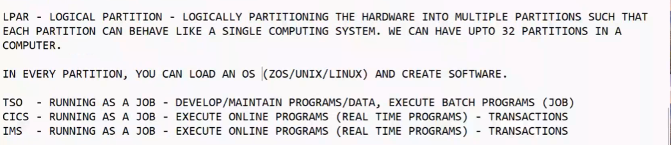

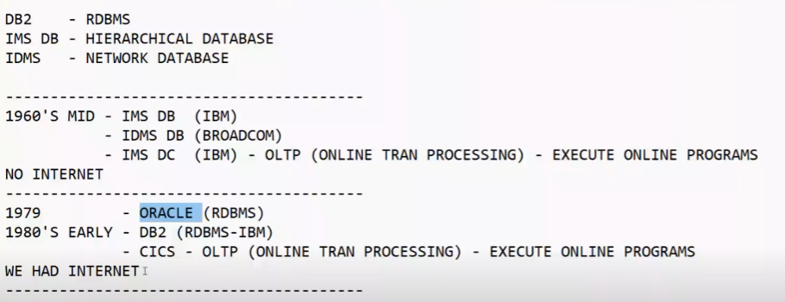

Mainframe roles: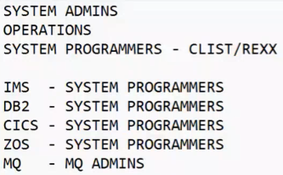

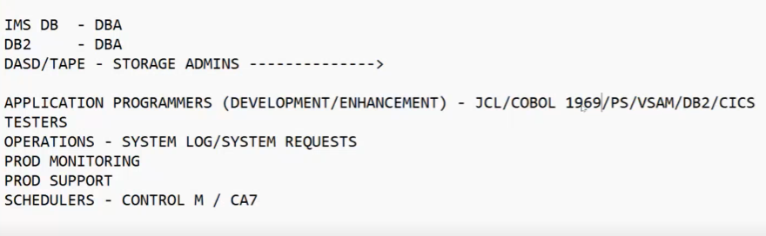

Ipl is like an operating system for windows but for mainframes: multiple different starts: cold will refresh, warm won’t refresh everything (most usually) and one more?

for migrate you have to know what is dasd

any job or anything access the job system you can see here: (in system requests)

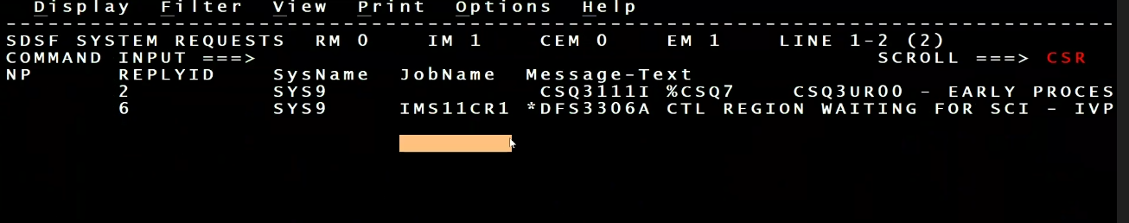

Get the request id and search it in ibm manual in google

I: INFORMATION

A: ACTION

W: WARNING

E: EvENTUAL ACTION

Need to be an expert in vsam for storage also learn about lds

Control m will connect unkile systems like mainframes etc with linux server etc

REDO THESE: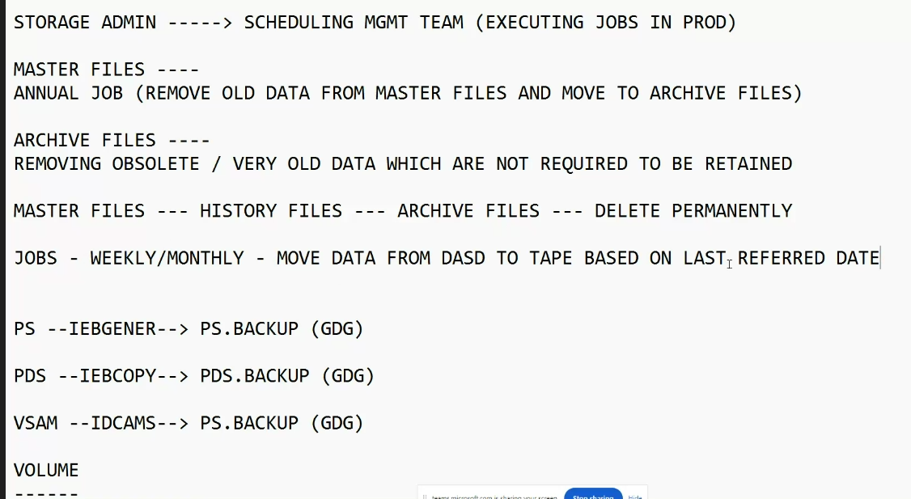

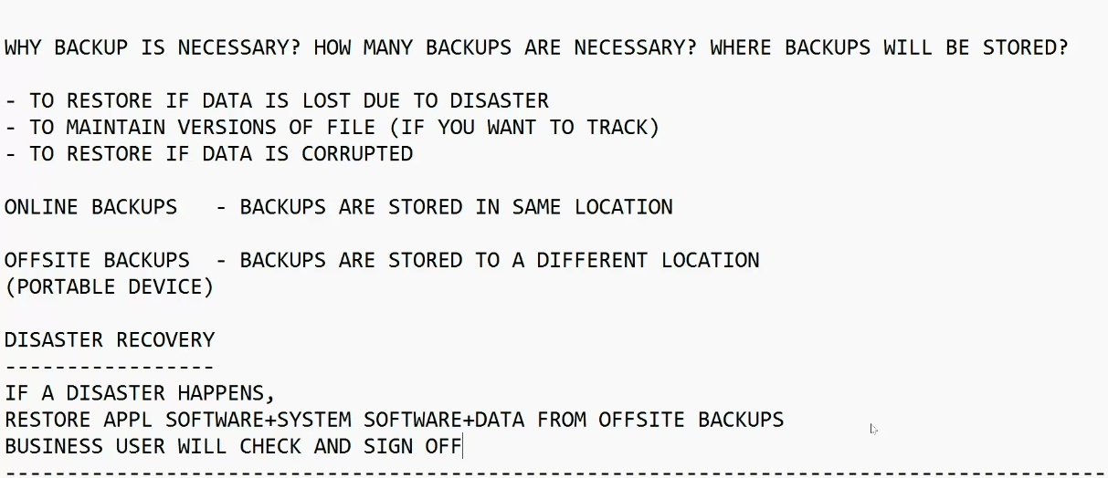

Every dataset that starts with SYS IS A SYSTEM DATASET SO view it in V not E

Watch first day hlaf lecture

Then notes  
LEARN ALIAS MASTER CATALOG watch recording after lunch

Then notes

Defining/creating alias

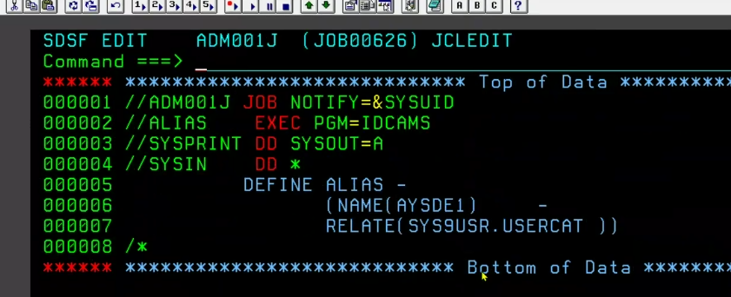

Deleting alias

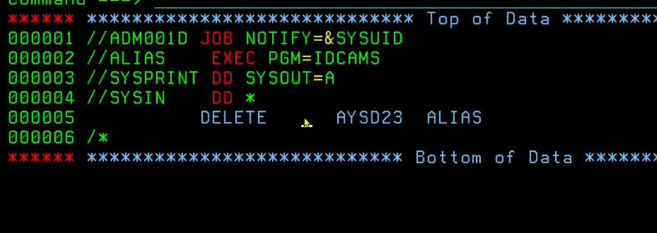

DEFINING UCAT

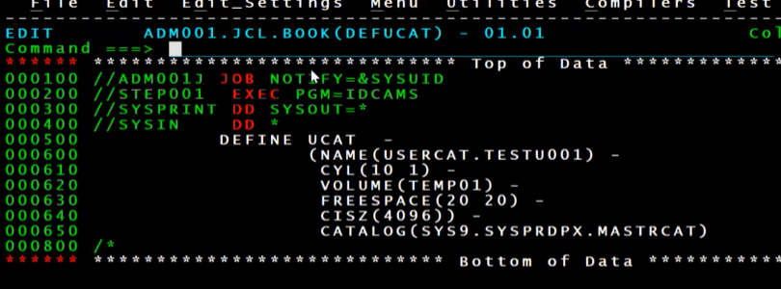

2:53 also at 4:15 HE SHOWS NOTES NOTEPAD - understand why catalog and its purpose

2:57 the ile wasnt deleted he just uncatalog

3:16 how many volumes in

4:44 he gives recap

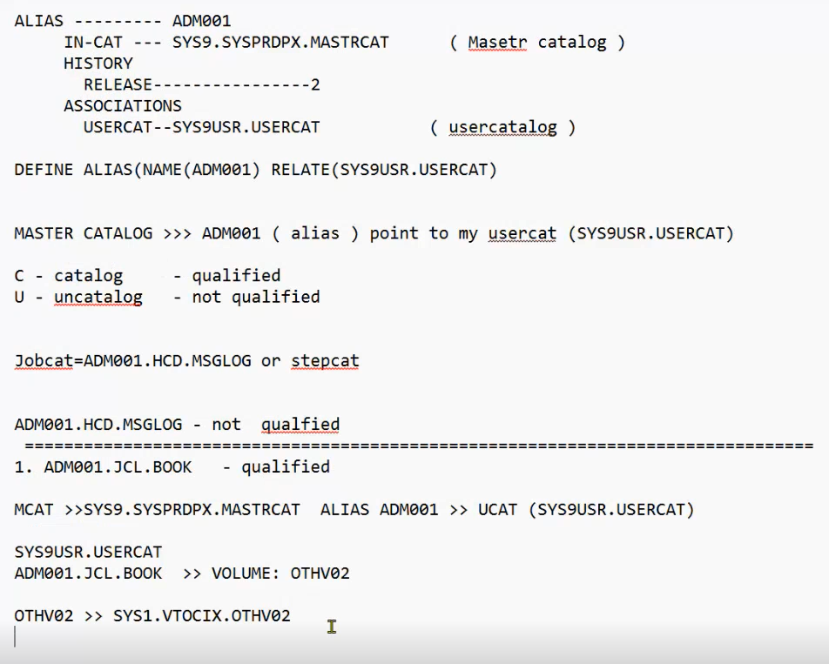

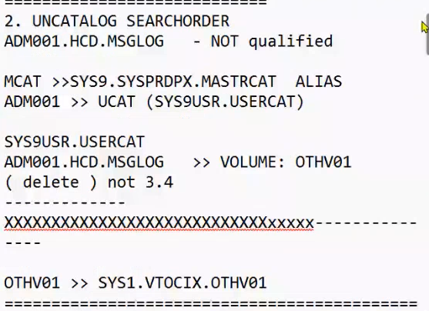

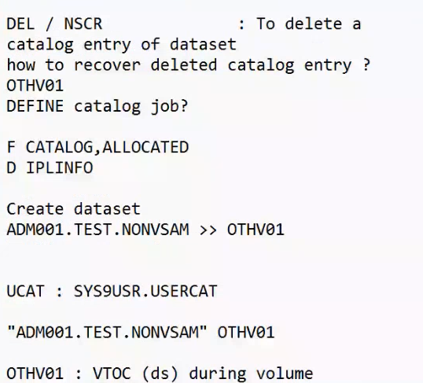

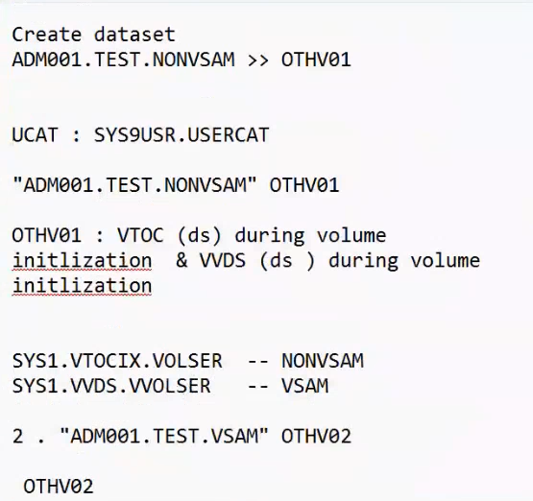

Migrating is moving files from one volume serial to another serial

RECAP day 1 then next two days read the student notes

What is sms why we call it sms why we contact to sms? What is prco, what is rules,

Online for dash if not online for offline has to be antoehr dasd or tape or archive

Active for only acds

Reorg when offline to minimise the ci splits

M queue important 1:45 pm

Lpar is like a virtual machine

1:59 they show about profile settings

Ignore abend question

Default storage class is userid

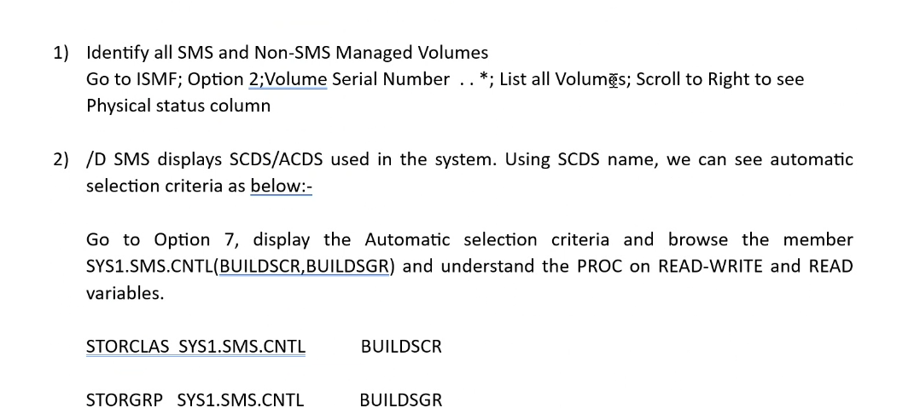

5) units=3390 ser=vol=othv2

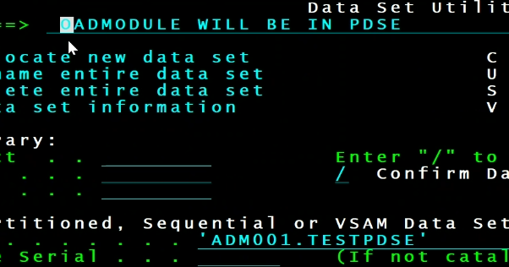

6) in panel remove the storage class and volume

7)

